|  |  |
| --- | --- |
| HealthStream Quick Reference  Job Aid - Access and Complete HealthStream Courses | |
| **Rev:** 11/19/24 | OPTIMIZATION & CLINICAL CONSULTING |

## Access HealthStream

1. [www.healthstream.com/hlc/trinityhealth](http://www.healthstream.com/hlc/trinityhealth)

**or**

1. Log in to the Trinity network using <https://connect.trinity-health.org> and select the HealthStream icon:

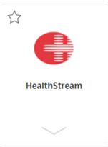

## Log In

* **Workforce ID** – Enter your Workforce ID/Employee ID
* **Password** – Enter the same HealthStream password as before the transition to the Trinity Health instance of HealthStream

Click 

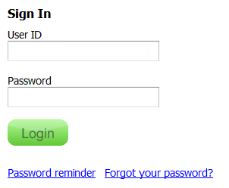

## Start Your Assigned Course

In your **My To-Do List**, click .

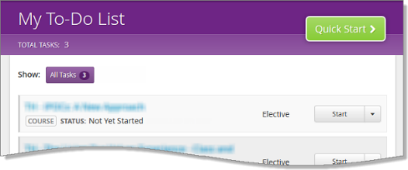

Click  to begin a lesson

**Navigation Tips:**

* If you stop in the middle of a lesson, HealthStream saves your place. To start where you left off, click .
* When you complete a lesson, it's marked by .
* If a lesson is , you must complete previous lessons first.
* After you complete a course, it will drop off your To-Do list and move to your Completed list.

## Log Out

When you're finished, click **Logout** at the top right of the page, under your name:

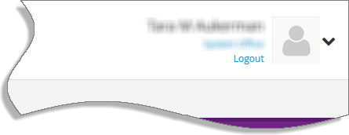

## Need Help?

1. Access [HealthStream](http://www.healthstream.com/hlc/trinityhealth)
2. Select “Help” from the toolbar



1. Select a topic

**Help Videos:**

* [How to Access HealthStream/Overview](https://trinityhealth.wistia.com/medias/sesbrl4ef4)
* [HealthStream My Team (Manager Training)](https://trinityhealth.wistia.com/medias/bxb3jpqozw)

**For additional help:**

1. If you’re unable to log into HealthStream, contact the Service Desk at 616-847-5570.
2. For additional questions, contact your manager.