

**CO**RONA**VI**RUS **D**ISEASE 2019   
(COVID-19)

**Social Posts – Fully Vaccinated Travel**

|  |
| --- |
| **Audience:** MarComm colleagues to post on social media |
| **Revision Date:** 4/14/2021 |
| **Version:** #1 |
| **COVID-19 Response Team Owner:** Clinical and Operations |
| **Date of Last Review:** 4/20/2021 |

Social Post #1 – Domestic Travel During COVID-19

Fully vaccinated against #COVID19? You can now safely travel within the United States. Follow these guidelines to protect yourself and others. [Domestic Travel During COVID-19 | CDC](https://www.cdc.gov/coronavirus/2019-ncov/travelers/travel-during-covid19.html#fully-vaccinated-people). #StaySafe

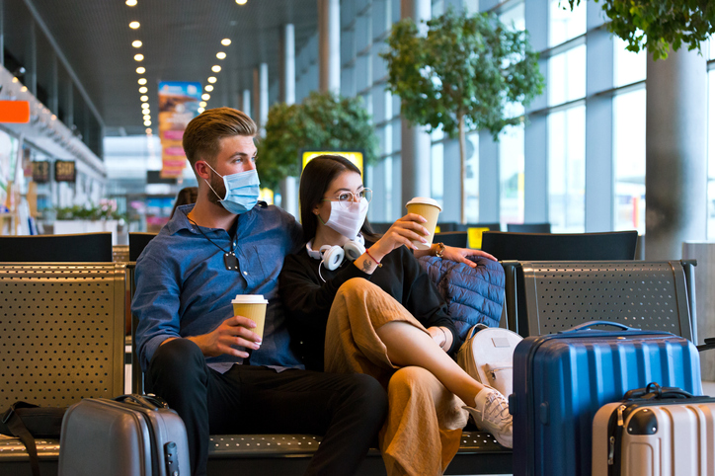

Social Post #2 – International Travel During COVID-19

Please avoid international travel at this time, as it is more involved and not highly recommended.

