

**Social Posts: How to spot a fake at-home COVID test**

**CO**RONA**VI**RUS **D**ISEASE 2019   
(COVID-19)

|  |
| --- |
| **Audience:** MarComm colleagues to post on social media |
| **Revision Date:** 1/11/2022 |
| **Version:** # 1 |
| **COVID-19 Response Team Owner:** Clinical and Operations |
| **Date of Last Review:** 1/13/2022 |

Social Media Content for How to Spot a Fake At-Home COVID Test

With COVID-19 cases surging across the United States, at-home COVID tests have been difficult to find. As a result, the Federal Trade Commission (FTC) and U.S. Food and Drug Administration (FDA) have seen an increase of fake tests being sold online.

Consider using the following social posts to educate consumers on spotting a fake at-home COVID test.

Social posts can be found in [Teams](https://mytrinityhealth.sharepoint.com/:f:/r/sites/MarCommEnterpriseTeamTHO365/Shared%20Documents/Social%20Media%20Collaborative/Graphics?csf=1&web=1&e=hN9viF) or on the [COVID-19 Resource Page](https://www.trinity-health.org/covid-19-resources/).

**Twitter – Fake Tests Overview**

Be on the lookout for fake at-home #COVID19 tests! Here’s how you can spot a fake ⤵️

▪️ Only buy authorized tests

▪️ Buy from a trusted seller

▪️ Research unfamiliar sellers

▪️ Use a credit card to purchase

**Facebook/LinkedIn – Fake Tests Overview**

The current COVID-19 surge has made it difficult to find home testing kits in stores and online. As a result, there has been a spike in fake at-home tests. Here are some steps you can take to avoid fake tests ⤵️

**▪️ Only buy authorized tests:** Check the FDA lists for authorized antigen tests or molecular tests

**▪️ Buy from a trusted seller:** Major pharmacy and retail stores sell tests online

**▪️ Research unfamiliar sellers:** Read the seller’s review or perform an online search for the seller’s names

**▪️ Use a credit card to purchase:** This way if you receive a fake test or don’t receive the package, you can dispute the charge with the credit card company.

**Instagram - Fake Tests Overview**

The current #COVID19 surge has made it difficult to find home testing kits in stores and online. As a result, there has been a spike in fake at-home tests. Here are some steps you can take to avoid fake tests ⤵️

**▪️ Only buy authorized tests:** Check the FDA lists for authorized antigen tests or molecular tests

**▪️ Buy from a trusted seller:** Major pharmacy and retail stores sell tests online

**▪️ Research unfamiliar sellers:** Read the seller’s review or perform an online search for the seller’s names

**▪️ Use a credit card to purchase:** This way if you receive a fake test or don’t receive the package, you can dispute the charge with the credit card company.

**Social Graphic – Fake Tests Overview**

[COVID-19_Spot a Fake Overview_1200x600](https://mytrinityhealth.sharepoint.com/:i:/r/sites/MarCommEnterpriseTeamTHO365/Shared%20Documents/Social%20Media%20Collaborative/Social%20Media%20Campaigns/COVID-19%20How%20to%20Spot%20Fake%20At%20Home%20COVID%20Tests/COVID-19_Spot%20a%20Fake%20Overview_1200x600.jpg?csf=1&web=1&e=XeTLvv)

[COVID-19_Spot a Fake Overview_1200x1200](https://mytrinityhealth.sharepoint.com/:i:/r/sites/MarCommEnterpriseTeamTHO365/Shared%20Documents/Social%20Media%20Collaborative/Social%20Media%20Campaigns/COVID-19%20How%20to%20Spot%20Fake%20At%20Home%20COVID%20Tests/COVID-19_Spot%20a%20Fake%20Overview_1200x1200.jpg?csf=1&web=1&e=2Bi6WR)

**Twitter – Fake Tests Infographic**

The @US_FDA has seen an increase in fake at-home #COVID19 tests being sold online. This isn’t just a waste of money, but it also increases the risk of spreading COVID.

Here’s how you can spot a fake ⤵️

**Facebook/LinkedIn – Fake Tests Infographic**

The FDA has seen an increase in fake at-home COVID-19 tests being sold online. This isn’t just a waste of money, but it also increases the risk of spreading COVID.

Here’s how you can spot a fake ⤵️

**Instagram -** **Fake Tests Infographic**

The FDA has seen an increase in fake at-home #COVID19 tests being sold online. This isn’t just a waste of money, but it also increases the risk of spreading COVID.

Here’s how you can spot a fake ⤵️

**Social Graphic – Fake Tests Infographic**

[THSO_911803643_How_to_spot_fake_at_home_tests_1200x1200_Trinity_Health](https://mytrinityhealth.sharepoint.com/:i:/r/sites/MarCommEnterpriseTeamTHO365/Shared%20Documents/Social%20Media%20Collaborative/Social%20Media%20Campaigns/COVID-19%20How%20to%20Spot%20Fake%20At%20Home%20COVID%20Tests/THSO_911803643_How_to_spot_fake_at_home_tests_1200x1200_Trinity_Health.png?csf=1&web=1&e=kr4GOe)

[THSO_911803643_How_to_spot_fake_at_home_tests_1200x600_Trinity_Health](https://mytrinityhealth.sharepoint.com/:i:/r/sites/MarCommEnterpriseTeamTHO365/Shared%20Documents/Social%20Media%20Collaborative/Social%20Media%20Campaigns/COVID-19%20How%20to%20Spot%20Fake%20At%20Home%20COVID%20Tests/THSO_911803643_How_to_spot_fake_at_home_tests_1200x600_Trinity_Health.png?csf=1&web=1&e=Sdcwce)

[THSO_911803643_How_to_spot_fake_at_home_tests_1200x1200_unbranded](http://kronos-wfc.no.trinity-health.org/wfc/logon/logonWFC.htmlhttps:/mytrinityhealth.sharepoint.com/:i:/r/sites/MarCommEnterpriseTeamTHO365/Shared%20Documents/Social%20Media%20Collaborative/Social%20Media%20Campaigns/COVID-19%20How%20to%20Spot%20Fake%20At%20Home%20COVID%20Tests/THSO_911803643_How_to_spot_fake_at_home_tests_1200x1200_unbranded.png?csf=1&web=1&e=iO133U)

[THSO_911803643_How_to_spot_fake_at_home_tests_1200x600_unbranded](https://mytrinityhealth.sharepoint.com/:i:/r/sites/MarCommEnterpriseTeamTHO365/Shared%20Documents/Social%20Media%20Collaborative/Social%20Media%20Campaigns/COVID-19%20How%20to%20Spot%20Fake%20At%20Home%20COVID%20Tests/THSO_911803643_How_to_spot_fake_at_home_tests_1200x600_unbranded.png?csf=1&web=1&e=y3slh8)

**Twitter – FDA List of Approved Tests**

With the increase of fake at-home #COVID19 tests being sold online, the @US_FDA has provided a list of authorized antigen and molecular tests. Check them out before you buy

Antigen tests: [In Vitro Diagnostics EUAs - Antigen Diagnostic Tests for SARS-CoV-2 | FDA](https://www.fda.gov/medical-devices/coronavirus-disease-2019-covid-19-emergency-use-authorizations-medical-devices/in-vitro-diagnostics-euas-antigen-diagnostic-tests-sars-cov-2)

Molecular tests: [In Vitro Diagnostics EUAs - Molecular Diagnostic Tests for SARS-CoV-2 | FDA](https://www.fda.gov/medical-devices/coronavirus-disease-2019-covid-19-emergency-use-authorizations-medical-devices/in-vitro-diagnostics-euas-molecular-diagnostic-tests-sars-cov-2)

**Facebook/LinkedIn – FDA List of Approved Tests**

With the increase of fake at-home COVID-19 tests being sold online, the FDA has provided a list of authorized antigen and molecular tests. Check them out before you buy

Antigen tests: [In Vitro Diagnostics EUAs - Antigen Diagnostic Tests for SARS-CoV-2 | FDA](https://www.fda.gov/medical-devices/coronavirus-disease-2019-covid-19-emergency-use-authorizations-medical-devices/in-vitro-diagnostics-euas-antigen-diagnostic-tests-sars-cov-2)

Molecular tests: [In Vitro Diagnostics EUAs - Molecular Diagnostic Tests for SARS-CoV-2 | FDA](https://www.fda.gov/medical-devices/coronavirus-disease-2019-covid-19-emergency-use-authorizations-medical-devices/in-vitro-diagnostics-euas-molecular-diagnostic-tests-sars-cov-2)

**Instagram - FDA List of Approved Tests**

With the increase of fake at-home #COVID19 tests being sold online, the @US_FDA has provided a list of authorized antigen and molecular tests. Check them out before you buy – Link in bio.

** ADD ONE OF THE FOLLOWING LINKS TO YOUR BIO**

Antigen tests: [In Vitro Diagnostics EUAs - Antigen Diagnostic Tests for SARS-CoV-2 | FDA](https://www.fda.gov/medical-devices/coronavirus-disease-2019-covid-19-emergency-use-authorizations-medical-devices/in-vitro-diagnostics-euas-antigen-diagnostic-tests-sars-cov-2)

Molecular tests: [In Vitro Diagnostics EUAs - Molecular Diagnostic Tests for SARS-CoV-2 | FDA](https://www.fda.gov/medical-devices/coronavirus-disease-2019-covid-19-emergency-use-authorizations-medical-devices/in-vitro-diagnostics-euas-molecular-diagnostic-tests-sars-cov-2)

**Social Graphic – FDA List of Approved Tests**

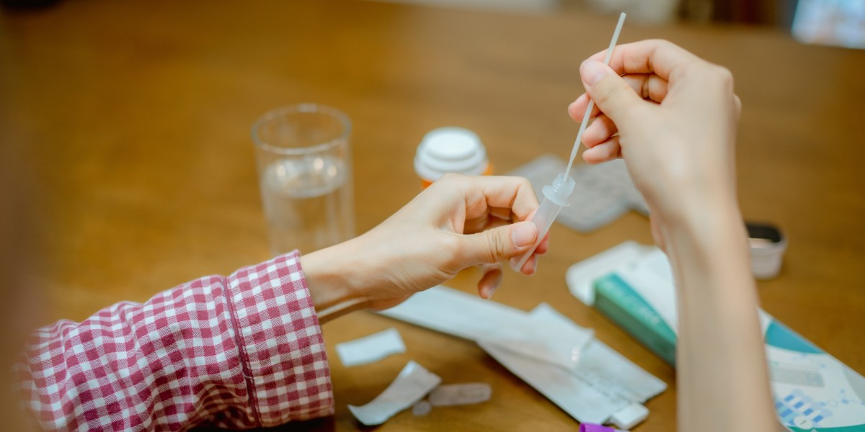

[COVID-19_FDA List of Approved Tests_1200x1200](https://mytrinityhealth.sharepoint.com/:i:/r/sites/MarCommEnterpriseTeamTHO365/Shared%20Documents/Social%20Media%20Collaborative/Social%20Media%20Campaigns/COVID-19%20How%20to%20Spot%20Fake%20At%20Home%20COVID%20Tests/COVID-19_FDA%20List%20of%20Approved%20Tests_1200x1200.jpg?csf=1&web=1&e=VbVrEy)

[COVID-19 FDA List of Approved Tests_1200x600](https://mytrinityhealth.sharepoint.com/:i:/r/sites/MarCommEnterpriseTeamTHO365/Shared%20Documents/Social%20Media%20Collaborative/Social%20Media%20Campaigns/COVID-19%20How%20to%20Spot%20Fake%20At%20Home%20COVID%20Tests/COVID-19_FDA%20List%20of%20Approved%20Tests_1200x600.jpg?csf=1&web=1&e=93GjHt)

**Twitter – Use a Credit Card**

When buying at-home #COVID19 tests be sure to use a credit card 💳, especially if it’s from an unfamiliar seller. This way if you receive a fake test or don’t receive the package, you can dispute the charge with the credit card company.

Learn more: [LINK TO ARTICLE ON YOUR WEBSITE] - **\*only if you used the How to Spot a Fake at Home COVID Test article\***

**Facebook/LinkedIn – Use a Credit Card**

When buying at-home COVID-19 tests be sure to use a credit card 💳, especially if it’s from an unfamiliar seller. This way if you receive a fake test or don’t receive the package, you can dispute the charge with the credit card company.

Learn more: [LINK TO ARTICLE ON YOUR WEBSITE] - **\*only if you used the How to Spot a Fake at Home COVID Test article\***

**Instagram - Use a Credit Card**

When buying at-home #COVID19 tests be sure to use a credit card 💳, especially if it’s from an unfamiliar seller. This way if you receive a fake test or don’t receive the package, you can dispute the charge with the credit card company.

Learn more: [LINK TO ARTICLE ON YOUR WEBSITE] - **\*only if you used the How to Spot a Fake at Home COVID Test article\***

**Social Graphic – Use a Credit Card**

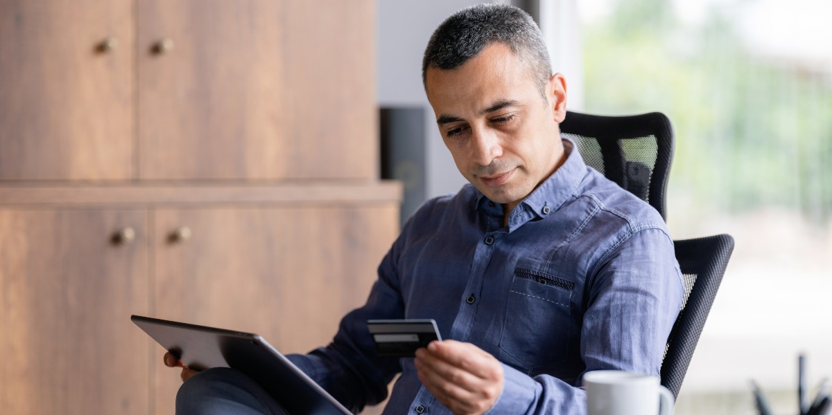

[COVID-19 Use a Credit Card_1200x1200](https://mytrinityhealth.sharepoint.com/:i:/r/sites/MarCommEnterpriseTeamTHO365/Shared%20Documents/Social%20Media%20Collaborative/Social%20Media%20Campaigns/COVID-19%20How%20to%20Spot%20Fake%20At%20Home%20COVID%20Tests/COVID-19_Use%20a%20Credit%20Card_1200x1200.jpg?csf=1&web=1&e=ZdZQNE)

[COVID-19_Use a Credit Card_1200x600](https://mytrinityhealth.sharepoint.com/:i:/r/sites/MarCommEnterpriseTeamTHO365/Shared%20Documents/Social%20Media%20Collaborative/Social%20Media%20Campaigns/COVID-19%20How%20to%20Spot%20Fake%20At%20Home%20COVID%20Tests/COVID-19_Use%20a%20Credit%20Card_1200x600.jpg?csf=1&web=1&e=81ePm7)