

**CO**RONA**VI**RUS **D**ISEASE 2019   
(COVID-19)

**Social Posts – Fully Vaccinated**

|  |
| --- |
| **Audience:** MarComm colleagues to post on social media |
| **Revision Date:** 3/17/2021 |
| **Version:** Version # 2 |
| **COVID-19 Response Team Owner:** Clinical and Operations |
| **Date of Last Review:** 3/17/2021 |

Social Post #1: When am I fully vaccinated?

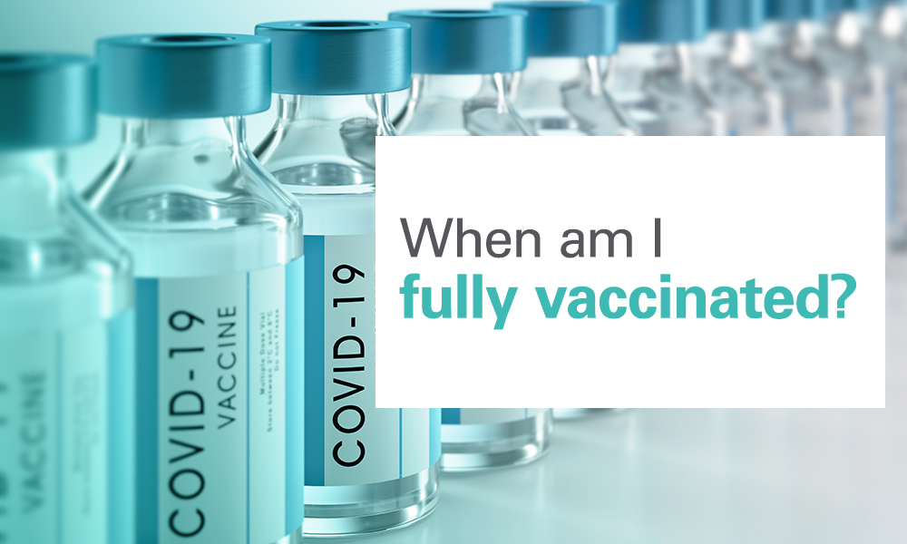

**When am I fully vaccinated?**  
You are fully vaccinated against #COVID19 two weeks after receiving the second dose in a two-dose series, or two weeks after receiving a single-dose #vaccine.

Social Post #2: Once I’m fully vaccinated, can I visit others?

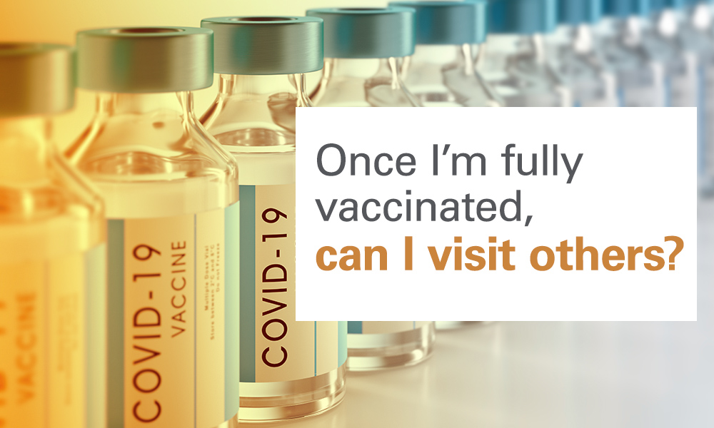

**Once I’m fully vaccinated, can I visit others?**If you’re fully vaccinated, you can visit with other fully vaccinated people indoors without masks or physical distancing. You can also visit with unvaccinated people from a single household who are at low risk for severe #COVID19. #vaccine

Social Post #3: Do fully vaccinated people need to quarantine and test after COVID-19 exposure?

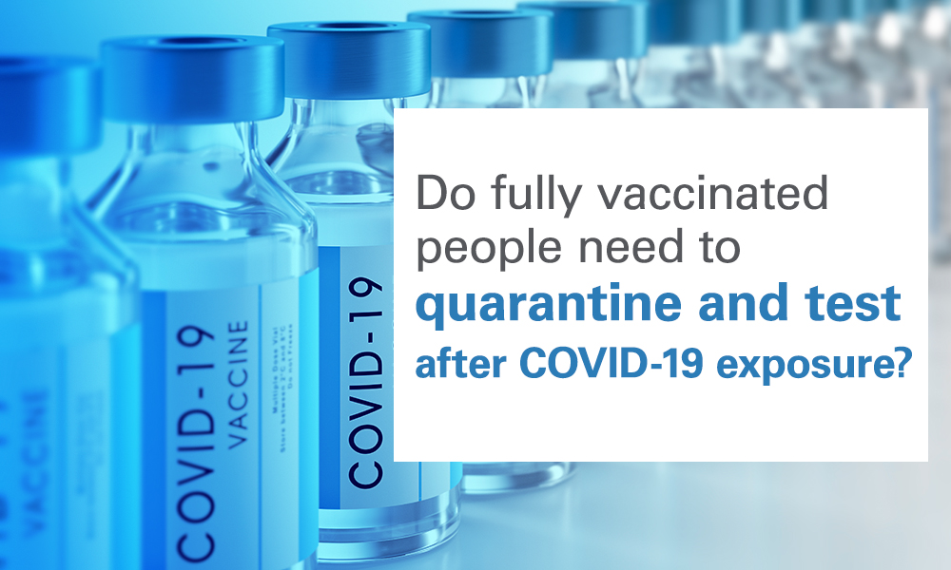

**Do fully vaccinated people need to quarantine and test after COVID-19 exposure?**No. If you’re fully vaccinated and do not work in health care, you do not need to quarantine or test following a known exposure as long as you have no #COVID19 symptoms. #vaccine

Social Post #4: Do fully vaccinated people still need to take precautions?

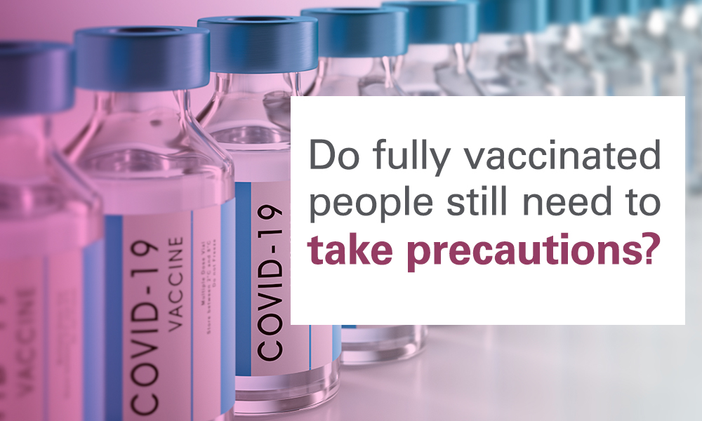

**Do fully vaccinated people still need to take precautions?**  
Even if you’re fully vaccinated you should still take precautions in public including wearing a mask and keeping physical distance. These measures should also be taken when visiting with unvaccinated people who are at increased risk for severe #COVID19, or when visiting with unvaccinated people from multiple households. You should also continue to avoid medium- and large-sized in-person gatherings. #vaccine

Social Post #5: I’ve been fully vaccinated but am having COVID-19 symptoms. Should I get tested?

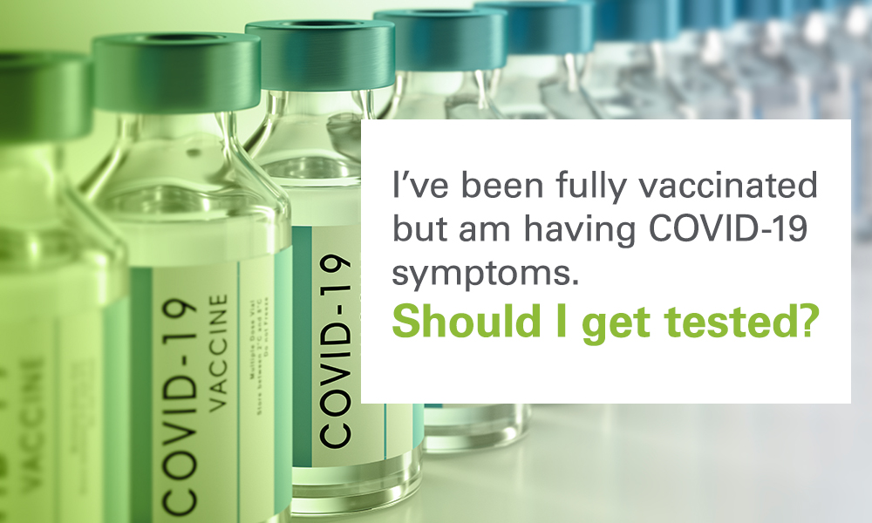

**I’ve been fully vaccinated but am having COVID-19 symptoms. Should I get tested?**Yes. You should get tested if you are experiencing #COVID19 symptoms. Vaccination is extremely effective, but it is still possible to contract COVID-19 after receiving a #vaccine because of variants and more.

Social Post #6: Can I travel after I’m vaccinated?

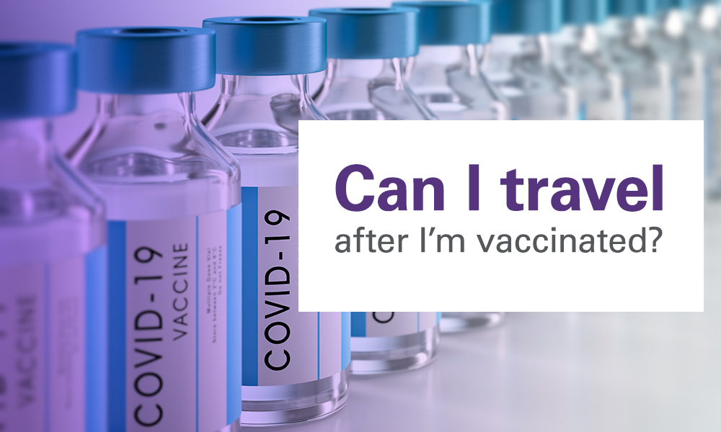

**Can I travel after I’m vaccinated?**The CDC recommends delaying travel and staying home, even if you’re fully vaccinated, to protect yourself and others from COVID-19. Travel increases your chance of getting and spreading #COVID19. #vaccine

Social Post #7: Socializing for Fully Vaccinated People

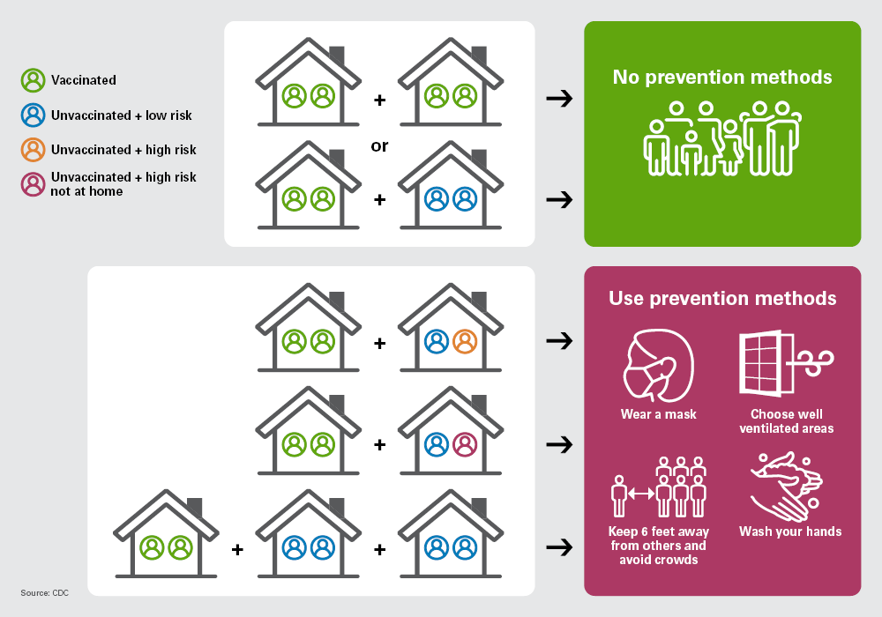

CDC offers this guide to social interactions with others and the prevention methods you should use to lower the risk of getting or spreading #COVID19.