

**Social Posts – Updated CDC Isolation and Quarantine Guidelines**

**CO**RONA**VI**RUS **D**ISEASE 2019   
(COVID-19)

|  |
| --- |
| **Audience:** MarComm colleagues to post on social media |
| **Revision Date:** 12/28/2021 |
| **Version:** # 1 |
| **COVID-19 Response Team Owner:** Clinical and Operations |
| **Date of Last Review:** 12/28/2021 |

Social Media Content for Updated CDC Isolation and Quarantine Guidelines

On Dec. 27, 2021, the CDC shortened the recommended time for isolation from 10 days for people with COVID-19 to five days, if asymptomatic, followed by 5 days of wearing a mask when around others. Additionally, CDC updated the recommended quarantine period for those exposed to COVID-19. For those who are not vaccinated or are more then six months out from their second mRNA dose (or more than two months after the J&J vaccine) and not yet boosted, CDC recommends quarantine for five days followed by a strict mask use for an additional five days. However, those who have received a booster shot did not need to quarantine following exposure but should wear a mask for 10 days after the exposure. The following social media content will educate individuals on the updated recommendations.

**Twitter – Updated Guidelines Overview**

@CDCgov has shortened the recommended #COVID19 isolation and quarantine period. Here’s what to do if you test positive or come in close contact with someone ⤵️

Learn more: [Isolation and Quarantine Period](https://www.cdc.gov/media/releases/2021/s1227-isolation-quarantine-guidance.html)

**Facebook/LinkedIn – Updated Guidelines Overview**

The CDC has shortened the recommended COVID-19 isolation and quarantine period. Here’s what to do if you test positive or come in close contact with someone ⤵️

Learn more: [Isolation and Quarantine Period](https://www.cdc.gov/media/releases/2021/s1227-isolation-quarantine-guidance.html)

**Social Graphic – Updated Guidelines Overview**

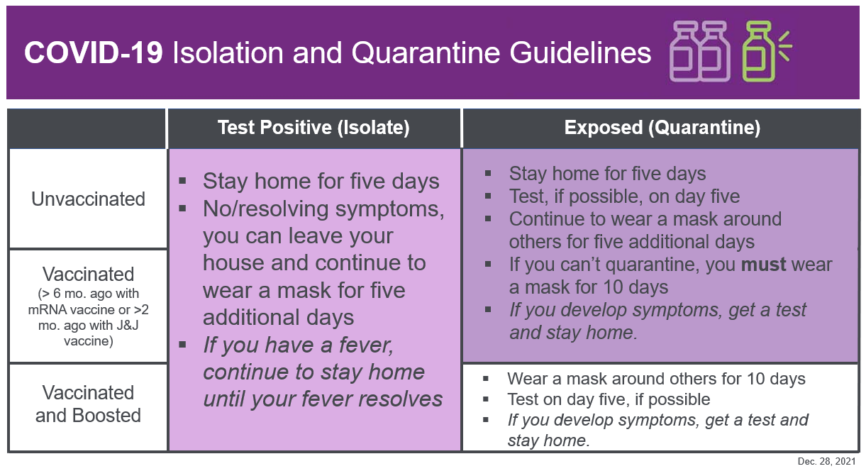

**Twitter – Test Positive (Isolate)**

Recently, **@CDCgov** shortened the #COVID19 isolation period. If you test positive, you should stay home for 5 days, leave your house if you have no/resolving symptoms, and continue to wear a mask for 5 additional days.

Learn more: [Isolation and Quarantine Period](https://www.cdc.gov/media/releases/2021/s1227-isolation-quarantine-guidance.html)

**Facebook/LinkedIn – Test Positive (Isolate)**

Recently, the CDC shortened the #COVID19 isolation period. If you test positive, you should do the following 𝙧𝙚𝙜𝙖𝙧𝙙𝙡𝙚𝙨𝙨 𝙤𝙛 𝙫𝙖𝙘𝙘𝙞𝙣𝙖𝙩𝙞𝙤𝙣 𝙨𝙩𝙖𝙩𝙪𝙨 ⤵️

▪️ Stay home for 5 days

▪️ Can leave your house if you have no or resolving symptoms

▪️ Continue to wear a mask for 5 additional days

𝘐𝘧 𝘺𝘰𝘶 𝘩𝘢𝘷𝘦 𝘢 𝘧𝘦𝘷𝘦𝘳, 𝘴𝘵𝘢𝘺 𝘩𝘰𝘮𝘦 𝘶𝘯𝘵𝘪𝘭 𝘺𝘰𝘶𝘳 𝘧𝘦𝘷𝘦𝘳 𝘳𝘦𝘴𝘰𝘭𝘷𝘦𝘴

Learn more: [Isolation and Quarantine Period](https://www.cdc.gov/media/releases/2021/s1227-isolation-quarantine-guidance.html)

**Social Graphic – Test Positive (Isolate)**



**Twitter – Exposed (Quarantine)**

Recently, **@CDCgov** shortened the #COVID19 quarantine period. If you are exposed, you should do the following based on your vaccination status ⤵️

Learn more: [Isolation and Quarantine Period](https://www.cdc.gov/media/releases/2021/s1227-isolation-quarantine-guidance.html)

**Facebook/LinkedIn – Exposed (Quarantine)**

Recently, the CDC shortened the #COVID19 quarantine period. If you are exposed, you should do the following based on your vaccination status ⤵️

Learn more: [Isolation and Quarantine Period](https://www.cdc.gov/media/releases/2021/s1227-isolation-quarantine-guidance.html)

**Social Graphic – Exposed (Quarantine)**

