

**Social Posts – COVID-19 Vaccines and Kids (ages 5-11)**

**CO**RONA**VI**RUS **D**ISEASE 2019   
(COVID-19)

|  |
| --- |
| **Audience:** MarComm colleagues to post on social media |
| **Revision Date:** 11/15/2021 |
| **Version:** # 1 |
| **COVID-19 Response Team Owner:** Clinical and Operations |
| **Date of Last Review:** 11/15/2021 |

COVID-19 Vaccines and Kids (ages 5-11)

**Concept:** Kids and the COVID-19 vaccine – Should I worry the vaccine is too “new”?

**Facebook & LinkedIn:** Kids and the COVID-19 Vaccine: What Parents Need to Know.

Should I worry the vaccine is too “new”? No.

As of October 2021, more than 6.63 billion doses of the COVID-19 vaccine have been given worldwide. The vaccine research for mRNA started in 1961 and, over the last decade specifically, was focused on SARS. Which helped the vaccine release more quickly into the community because the production started before the clinical trials.

Learn more: [**bit.ly/3oeP1Up**](http://bit.ly/3oeP1Up)

Source: CDC

**Twitter:** Should I worry the vaccine is too “new” for my child? No.

The mRNA research began in 1961 and, over the last decade specifically, was focused on SARS. This helped the vaccine release more quickly because the production started before the clinical trials.

Learn more: [**bit.ly/3oeP1Up**](http://bit.ly/3oeP1Up)

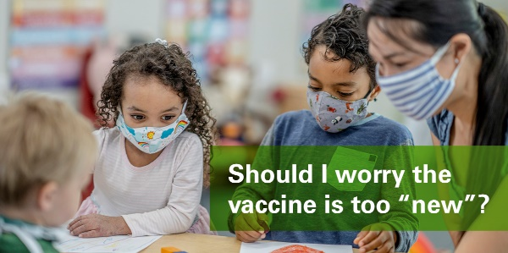

**Concept:** Kids and the COVID-19 vaccine – My child had COVID. Do they need the vaccine?

**Facebook & LinkedIn:** Kids and the COVID-19 Vaccine: What Parents Need to Know.

My child had COVID. Do they need the vaccine? Yes.

We know that “natural immunity” can be high at first. However, protection can drop off quickly or change based on circulating variants. Getting the vaccine, even if you have already had COVID-19, strengths your immune response.

Learn more: [INSERT CDC LINK]

Source: CDC

**Twitter:** My child had **#COVID**. Do they need the vaccine? Yes.  
  
We know that “natural immunity” can be high at first. But protection can drop off quickly or change based on variants. Even if you had COVID, the **#vaccine** strengths your immune response.  
  
Learn more [**bit.ly/3oeP1Up**](http://bit.ly/3oeP1Up)

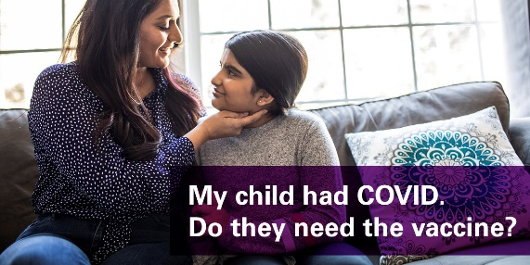

**Concept:** Kids and the COVID-19 vaccine – What are the ingredients?

**Facebook & LinkedIn:** Kids and the COVID-19 Vaccine: What Parents Need to Know.  
  
What are the ingredients in the **#COVID** mRNA vaccine? Put simply, it’s fat, salt, electrolytes and sugar.  
  
Lipids: This “fatty layer” protects the delicate mRNA so it has time to work before getting chopped up. Polyethylene glycol (PEG), the most famous lipid, is also the main ingredient in a common laxative.  
  
Learn more: [**bit.ly/3oeP1Up**](http://bit.ly/3oeP1Up)

Source: CDC

**Proposed Post Copy (Twitter):** What are the ingredients in the **#COVID** mRNA vaccine? Put simply, it’s fat, salt, electrolytes and sugar.  
  
Lipids: This “fatty layer” protects the delicate mRNA so it has time to work before getting chopped up.

Learn more: [**bit.ly/3oeP1Up**](http://bit.ly/3oeP1Up)

**Concept:** Kids and the COVID-19 vaccine – Is there less quarantine from school, sports or activities if vaccinated?

**Facebook & LinkedIn:** Kids and the COVID-19 Vaccine: What Parents Need to Know.  
  
Is there less quarantine from school, sports or activities if vaccinated? Yes.  
  
Based on the State of Michigan’s current guidelines, students who are vaccinated and exposed to COVID-19 can remain in school and wear a mask.  
  
Learn more: [**https://bit.ly/3oeP1Up**](https://bit.ly/3oeP1Up)

Source: CDC

**Twitter:** Is there less quarantine from school, sports or activities if vaccinated? Yes.  
  
Based on the State of Michigan’s current guidelines, students who are vaccinated and exposed to **#COVID19** can remain in school and wear a mask.  
  
Learn more: [**bit.ly/3oeP1Up**](http://bit.ly/3oeP1Up)

**Concept:** Kids and the COVID-19 vaccine – What are the most common side effects for kids?

**Facebook & LinkedIn:** Kids and the COVID-19 Vaccine: What Parents Need to Know.  
  
Will we need booster shots every year? We don’t know yet.  
  
It depends on how many people get vaccinated and if the virus continues to spread and change. As the population becomes vaccinated, we reduce the spread of the virus, which helps to prevent it from continuing to change.  
  
Learn more: [**https://bit.ly/3oeP1Up**](https://bit.ly/3oeP1Up)

Source: CDC

**Twitter:** Will we need booster shots every year? We don’t know yet.  
  
It depends on how many people get vaccinated and if the virus continues to spread and change. As the population becomes vaccinated, we reduce the spread of the virus.  
  
Learn more: [**bit.ly/3oeP1Up**](http://bit.ly/3oeP1Up)

**Concept:** Kids and the COVID-19 vaccine – What are the most common side effects for kids?

**Facebook & LinkedIn:** Kids and the COVID-19 Vaccine: What Parents Need to Know.  
  
What are the most common side effects for kids? They can vary but are minimal.  
  
The side effects that have been reports are mild to moderate, including fever, fatigue, headache, chills, diarrhea or muscle aches. Most kids reported side effects with the second dose compared to the first.  
  
Learn more: [**https://bit.ly/3oeP1Up**](https://bit.ly/3oeP1Up)

Source: CDC

**Twitter:** What are the most common COVID-19 vaccine side effects for kids? They can vary but are minimal.  
  
Reported side effects have been are mild to moderate, some including fever, headache and chills - most reported after the second dose.  
  
Learn more: [**https://bit.ly/3oeP1Up**](https://bit.ly/3oeP1Up)

**Concept:** Kids and the COVID-19 vaccine – How do we know about long term side effects?

**Facebook & LinkedIn:** Kids and the COVID-19 Vaccine: What Parents Need to Know.

How do we know about long term side effects? Decades of research

Based on our knowledge of mRNA and the human body, we don’t expect long-term side effects since the vaccine breaks down in the body in 72 hours.

All vaccines, including the COVID-19 mRNA vaccines, concerning side effects have occurred within 6-8 weeks after injection. The history of science shows us that if there are no side effects in those first few weeks, we are confident that concerns that arise with any patient are unlikely related to any vaccine.

Learn more: [**https://bit.ly/3oeP1Up**](https://bit.ly/3oeP1Up)

Source: CDC

**Twitter:** How do we know about long term side effects of the COVID-19 vaccine in kids? Decades of research

Based on our knowledge of mRNA and the human body, we don’t expect long-term side effects since the vaccine breaks down in the body in 72 hours.

Learn more:  [**https://bit.ly/3oeP1Up**](https://bit.ly/3oeP1Up)



**Concept:** Kids and the COVID-19 vaccine – Does it affect puberty or fertility?

**Facebook & LinkedIn:** Kids and the COVID-19 Vaccine: What Parents Need to Know.

Does it affect puberty or fertility? No

Based on our knowledge of mRNA vaccines, we are confident that the COVID-19 vaccine will not have long-term effects on puberty or fertility. The vaccine ingredients cannot integrate with DNA or alter cells. Additionally, the ingredients are cleared from the body quickly – within 72 hours.

Learn more: [**https://bit.ly/3oeP1Up**](https://bit.ly/3oeP1Up)

Source: CDC

**Twitter:** Does the COVID-19 vaccine affect puberty or fertility? No

Based on our knowledge of mRNA vaccines, we are confident that the COVID-19 vaccine will not have long-term effects on puberty or fertility.

Learn more: [**https://bit.ly/3oeP1Up**](https://bit.ly/3oeP1Up)

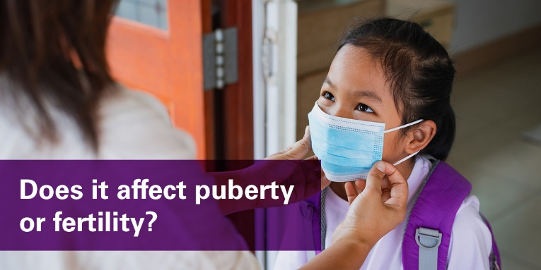

**Concept:** Kids and the COVID-19 vaccine – How common is Myocarditis for children after vaccination?

**Facebook & LinkedIn:** Kids and the COVID-19 Vaccine: What Parents Need to Know.

How common is Myocarditis for children after vaccination? Extremely rare.

Myocarditis means “inflammation” of the heart muscle. This can happen due to the robust immune response the vaccine can have on your body.

This condition is very rare and mild with the majority not requiring hospitalization. We expect 26 cases of myocarditis per 1 million doses given. That’s 0.0026%.

Learn more: [**https://bit.ly/3oeP1Up**](https://bit.ly/3oeP1Up)

Source: CDC

**Twitter:** How common is Myocarditis for children after COVID-19 vaccination? Extremely rare.

Myocarditis means “inflammation” of the heart muscle This condition is very rare and mild with the majority not requiring hospitalization.

Learn more: [**https://bit.ly/3oeP1Up**](https://bit.ly/3oeP1Up)

**Concept:** Kids and the COVID-19 vaccine – Can kids become very sick with COVID?

**Facebook & LinkedIn:** Kids and the COVID-19 Vaccine: What Parents Need to Know.

Can kids become very sick with COVID? Yes.

COVID-19 in kids can range from no symptoms to severe illness. As of October 2021, over 6.3 million COVID-19 pediatric cases have been reported.

However, since the pandemic started, over 600 pediatric deaths due to COVID-19 have been reports. It is now a top-10 cause of death for kids in the United States.

Learn more: [**https://bit.ly/3oeP1Up**](https://bit.ly/3oeP1Up)

Source: CDC

**Twitter:** Can kids become very sick with COVID? Yes.

COVID-19 in kids can range from no symptoms to severe illness. As of October 2021, over 6.3 million COVID-19 pediatric cases have been reported.

Learn more: [**https://bit.ly/3oeP1Up**](https://bit.ly/3oeP1Up)

