

**Social Posts – Emergency Care vs. Urgent Care vs. Virtual Care**

**CO**RONA**VI**RUS **D**ISEASE 2019   
(COVID-19)

|  |
| --- |
| **Audience:** MarComm colleagues to post on social media |
| **Revision Date:** 12/29/2021 |
| **Version:** # 1 |
| **COVID-19 Response Team Owner:** Marketing and Communications (PIO) |
| **Date of Last Review:** 12/29/2021 |

Emergency Care vs. Urgent Care vs. Virtual Care Social Media Content

With ministry emergency rooms extremely stretched thin with patients, here are some social media graphics to help explain to individuals what is considered an emergency.

**Twitter – Overview**

With the overwhelming pressures on the health care system due to the #COVID19 pandemic, it’s important to know what type of care you need when you are sick or injured.

Learn more: [LINK TO RHM THINK BEFORE YOU GO PAGE]

**Facebook/LinkedIn – Overview**

With the overwhelming pressures on the health care system due to the COVID-19 pandemic, it’s important to know what type of care you need when you are sick or injured.

Here is the difference between three types of care:

▪️ Virtual Care – Connects you to your provider using a computer or mobile phone

▪️ Urgent Care – Designed to evaluate and treat minor illnesses

▪️ Emergency Care – Should be sought anytime a condition is life-threatening

Learn more: [LINK TO RHM THINK BEFORE YOU GO PAGE]

**Instagram - Overview**

With the overwhelming pressures on the health care system due to the #COVID19 pandemic, it’s important to know what type of care you need when you are sick or injured.

Here is the difference between three types of care:

▪️ Virtual Care – Connects you to your provider using a computer or mobile phone

▪️ Urgent Care – Designed to evaluate and treat minor illnesses

▪️ Emergency Care – Should be sought anytime a condition is life-threatening

**Social Graphic – Overview**

WITH A DESIGNER

**Twitter – Where to go?**

Are you feeling sick or injured? But you’re unsure if you should visit the Emergency Room or Urgent Care?

Learn the difference before you go: [LINK TO RHM THINK BEFORE YOU GO LINK]

**Facebook/LinkedIn – Where to go?**

Are you feeling sick or injured? But you’re unsure if you should visit the Emergency Room or Urgent Care, or call your primary care physician?

Learn the difference before you go: [LINK TO RHM THINK BEFORE YOU GO LINK]

**Instagram – Where to go?**

Are you feeling sick or injured? But you’re unsure if you should visit the Emergency Room or Urgent Care, or call your primary care physician?

Learn the difference before you go. Link in bio

**Social Graphic – Where to go?**



**Twitter – Virtual Care**

Virtual Care is a quick and safe way to connect to you provider using a computer or mobile phone to diagnose and treat common and minor medical conditions like a cold/flu or a #COVID19 evaluation.

Learn more: [LINK TO RHM VIRTUAL CARE PAGE]

**Facebook/LinkedIn – Virtual Care**

Virtual Care is a quick and safe way to connect to you provider using a computer or mobile phone to diagnose and treat some of the following ⤵️

▪️ Common, minor medical conditions

▪️ Manage chronic conditions like diabetes

▪️ COVID-19 evaluation

▪️ Cold, sinus infection or flu

▪️ Female bladder infection (urinary tract infection)

▪️ Pink eye (conjunctivitis)

▪️ Vaginal yeast infection

Learn more: [LINK TO RHM VIRTUAL CARE PAGE]

**Instagram – Virtual Care**

Virtual Care is a quick and safe way to connect to you provider using a computer or mobile phone to diagnose and treat some of the following ⤵️

▪️ Common, minor medical conditions

▪️ Manage chronic conditions like diabetes

▪️ COVID-19 evaluation

▪️ Cold, sinus infection or flu

▪️ Female bladder infection (urinary tract infection)

▪️ Pink eye (conjunctivitis)

▪️ Vaginal yeast infection

Learn more: Link in bio

**Social Graphic – Virtual Care**



**Twitter – Urgent Care**

Urgent care centers provide easy access to quality health care when you need immediate care that is not life-threatening, but also can’t wait until the next day, or for a primary care doctor to see you.

Learn more: [LINK TO RHM URGENT CARE PAGE]

**Facebook/LinkedIn – Urgent Care**

Urgent care centers provide easy access to quality health care when you need immediate care that is not life-threatening, but also can’t wait until the next day, or for a primary care doctor to see you. Here’s when you should head to urgent care ⤵️

▪️ COVID-19 testing and evaluation

▪️ Muscle aches, minor sprains, abrasions

▪️ Flu, cough, cold and congestion

▪️ Bug bites, poison ivy, bruises

▪️ Minor cuts on extremities that might need a few stitches

Learn more: [LINK TO RHM URGENT CARE PAGE]

**Instagram – Urgent Care**

Urgent care centers provide easy access to quality health care when you need immediate care that is not life-threatening, but also can’t wait until the next day, or for a primary care doctor to see you. Here’s when you should head to urgent care ⤵️

▪️ COVID-19 testing and evaluation

▪️ Muscle aches, minor sprains, abrasions

▪️ Flu, cough, cold and congestion

▪️ Bug bites, poison ivy, bruises

▪️ Minor cuts on extremities that might need a few stitches

Learn more: Link in Bio

**Social Graphic – Urgent Care**

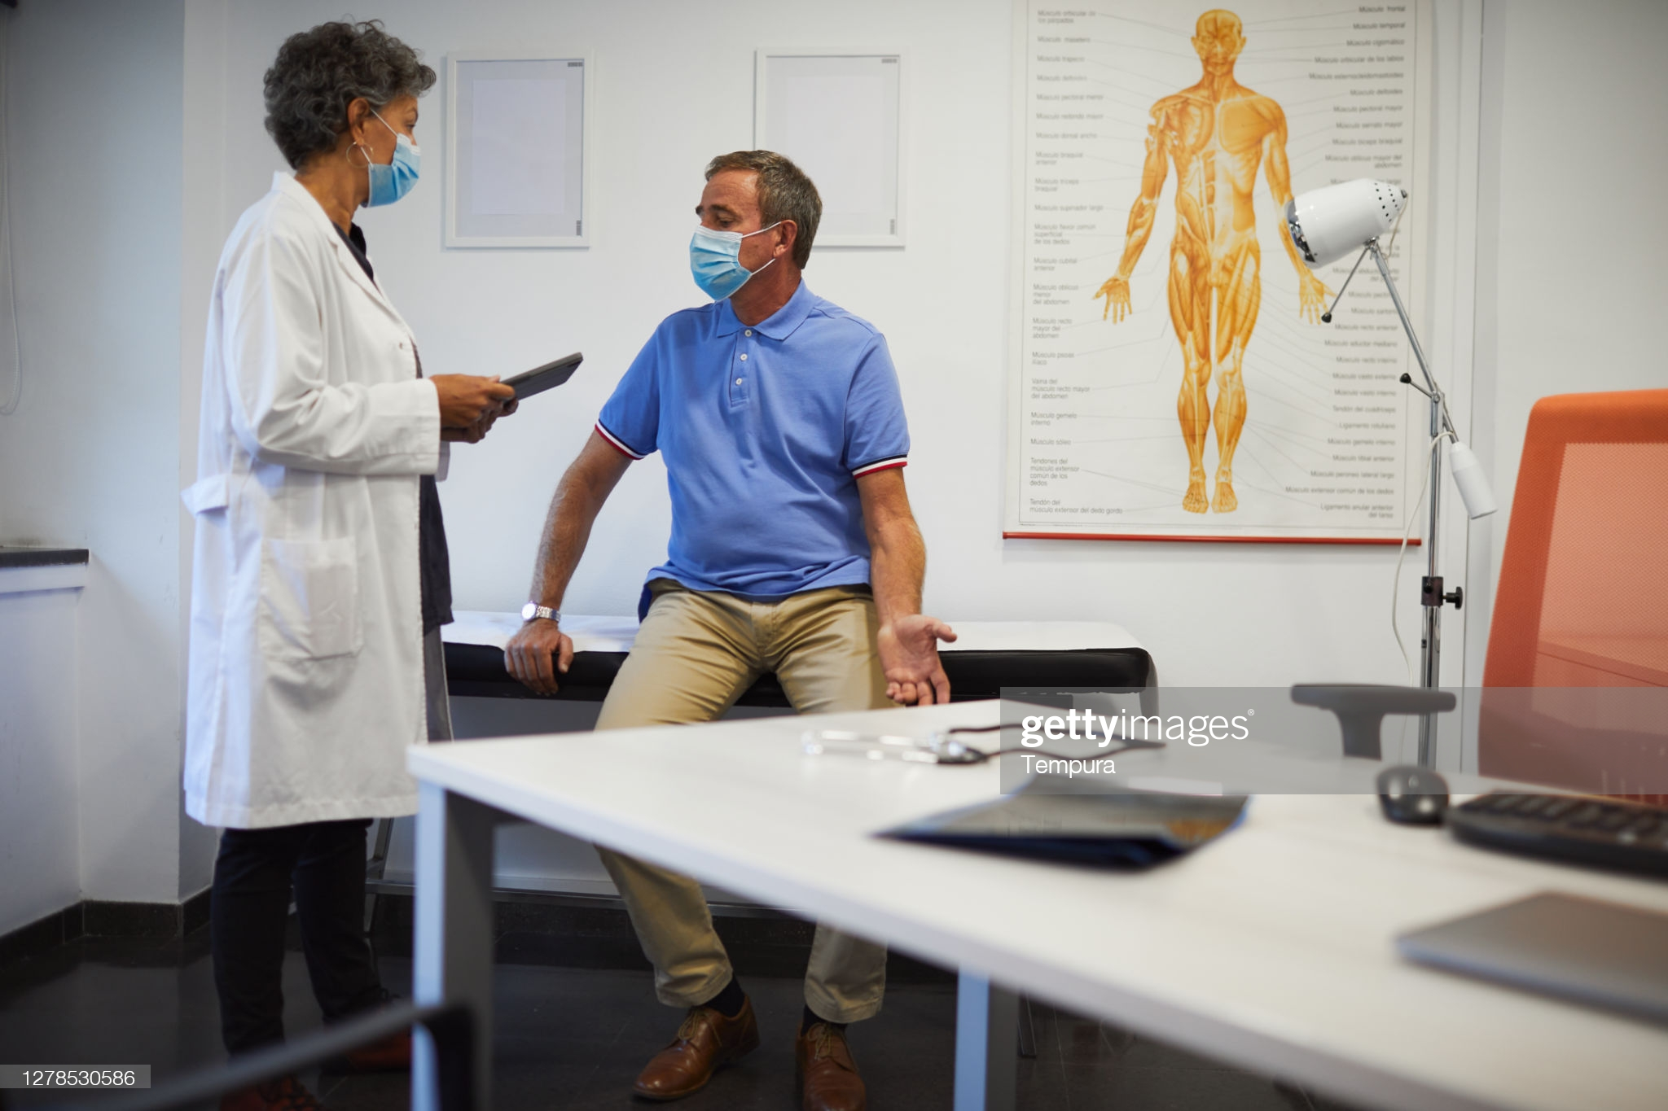

**Twitter – Emergency Care**

Emergency care should be sought anytime a condition is life-threatening, which may include chest pain, breathing problems, overdoses, or severe wound/injuries.

Dial 911 immediately for any medical problem that appears life-threatening.

Learn more: [LINK TO RHM EMERGENCY CARE PAGE]

**Facebook/LinkedIn – Emergency Care**

Emergency care should be sought anytime a condition is life-threatening, which may include the following ⤵️

▪️ Chest pain

▪️ Heart attack symptoms (Pain, pressure or squeezing in the center of the chest)

▪️ Stroke symptoms (Sudden numbness or weakness of the face, arm, or leg especially on one side of the body)

▪️ Persistent shortness of breath

▪️ Poisoning/Overdose

▪️ Serious head/neck/back injury

▪️ Severe wounds/severe cuts/amputations

▪️ Coughing up blood or vomiting blood

▪️ Suicidal or homicidal feelings

▪️ Any life-threatening injuries

▪️ Any limb-threatening injuries

Dial 911 **immediately** for any medical problem that appears life-threatening.

Don’t delay getting the care you need: [LINK TO RHM EMERGENCY CARE PAGE]

**Instagram – Emergency Care**

Emergency care should be sought anytime a condition is life-threatening, which may include the following ⤵️

▪️ Chest pain

▪️ Heart attack symptoms (Pain, pressure or squeezing in the center of the chest)

▪️ Stroke symptoms (Sudden numbness or weakness of the face, arm, or leg especially on one side of the body)

▪️ Persistent shortness of breath

▪️ Poisoning/overdose

▪️ Serious head/neck/back injury

▪️ Severe wounds/severe cuts/amputations

▪️ Coughing up blood or vomiting blood

▪️ Suicidal or homicidal feelings

▪️ Any life-threatening injuries

▪️ Any limb-threatening injuries

Dial 911 **immediately** for any medical problem that appears life-threatening.

Don’t delay getting the care you need: Link in bio

**Social Graphic – Emergency Care**

