Image File 1: Fact-Vaccine-Will-Not-Give-You-COVID

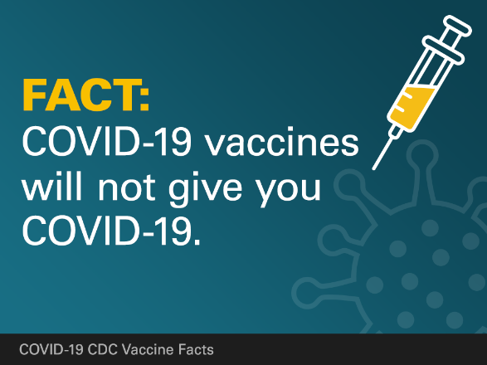

**FACT: COVID-19 vaccines will not give you COVID-19**

The COVID-19 vaccines being developed in the United States do not use the live virus and cannot cause COVID-19. The goal of any vaccine is to teach our immune systems how to recognize and fight a virus. However, symptoms such as fever can occur after you get a vaccine. These symptoms are normal and are a sign that the body is building immunity. Learn more about [how COVID-19 vaccines work](https://www.cdc.gov/coronavirus/2019-ncov/vaccines/about-vaccines/how-they-work.html) : https://www.cdc.gov/coronavirus/2019-ncov/vaccines/about-vaccines/how-they-work.html

Image File 2: Fact-Vaccine-Will-Not-Cause-You-To-Test-Positive

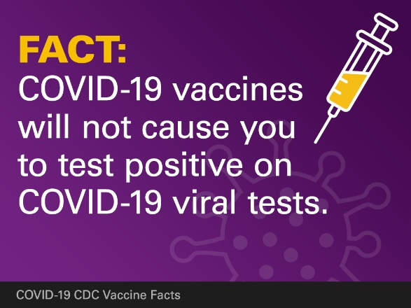

**FACT: COVID-19 vaccines will not cause you to test positive on COVID-19 viral tests**

You won’t get test positive on viral tests used to see if you have a **current infection** after getting the vaccine. However, some antibody tests might show you had a **previous COVID-19 infection**. This is because your body develops an immune response the vaccine. Experts are currently looking at how COVID-19 vaccination may affect antibody testing results. Learn more about COVID-19 testing: https://www.cdc.gov/coronavirus/2019-ncov/symptoms-testing/testing.html

Image File 3: Fact-People-Who-Have-Gotten-Sick

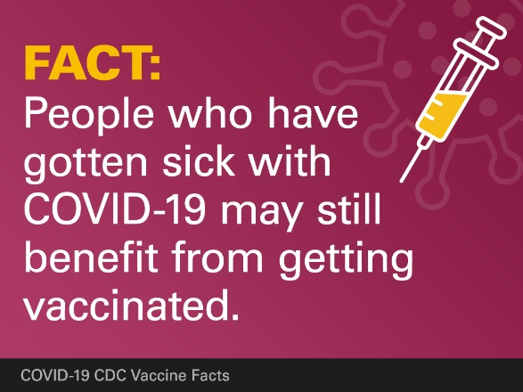 **FACT: People who have gotten sick with COVID-19 may still benefit from getting vaccinated**

Due to the severe health risks associated with COVID-19 and the fact that re-infection with is possible, some people who got sick with COVID-19 may be advised to get a COVID-19 vaccine.

At this time, it is unknown how long someone is protected from getting sick again after recovering from COVID-19. The amount immunity get from an infection, called natural immunity, varies from person to person and may not last very long.

Image File 4: Fact-Getting-Vaccinate-Can-Prevent

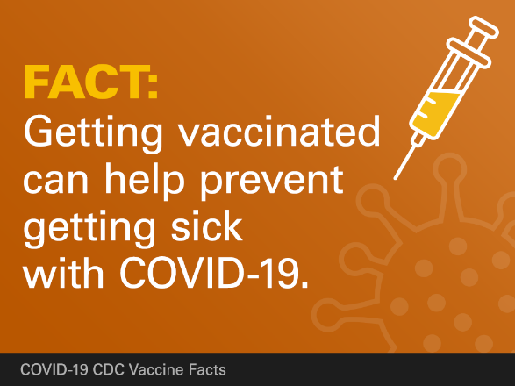

**FACT: Getting vaccinated can help prevent getting sick with COVID-19**

While COVID-19 may only cause a mild illness for some, others may get a severe illness, or they may even die. There is no way to know how COVID-19 will affect you, even if you are not at increased risk of severe complications. If you get sick, you also may spread the disease to friends, family, and others around you while you are sick. COVID-19 vaccination helps protect you by creating an antibody response without getting sick. Learn more about [how COVID-19 vaccines work](https://www.cdc.gov/coronavirus/2019-ncov/vaccines/about-vaccines/how-they-work.html): https://www.cdc.gov/coronavirus/2019-ncov/vaccines/about-vaccines/how-they-work.html

Image File 5: Fact-Receiving-An-mRNA

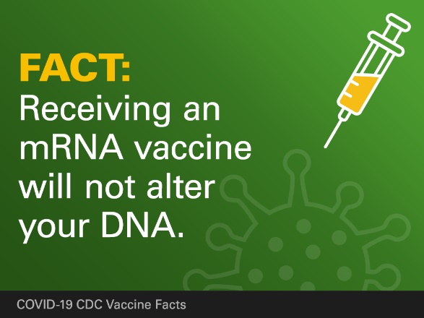

**FACT: Receiving an mRNA vaccine will not alter your DNA**

Messenger ribonucleic acid, or mRNA, and is most easily described as instructions for your body to make a protein or even just a piece of a protein. mRNA is not able to alter or modify a person’s genetic makeup (DNA). The mRNA from a COVID-19 vaccine never enter the nucleus of the cell, which is where our DNA are kept. This means the mRNA does not affect or interact with our DNA in any way. Instead, COVID-19 vaccines that use mRNA work with the body’s natural defenses to safely develop protection to disease. Learn more about how COVID-19 mRNA vaccines work:  ​https://www.cdc.gov/coronavirus/2019-ncov/vaccines/different-vaccines/mrna.html

Image File 6: How-Do-I-Know

## 

## How do I know which sources of COVID-19 vaccine information are accurate?

It can be difficult to know which sources of information you can trust. Learn more about finding credible vaccine information from the CDC: https://www.cdc.gov/vaccines/vac-gen/evalwebs.htm