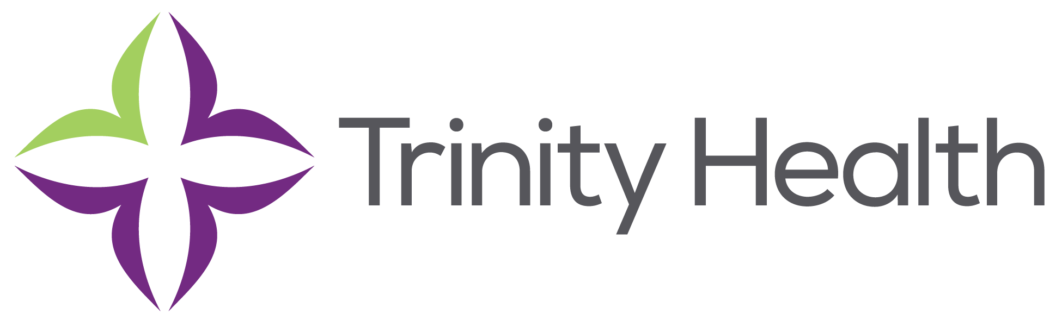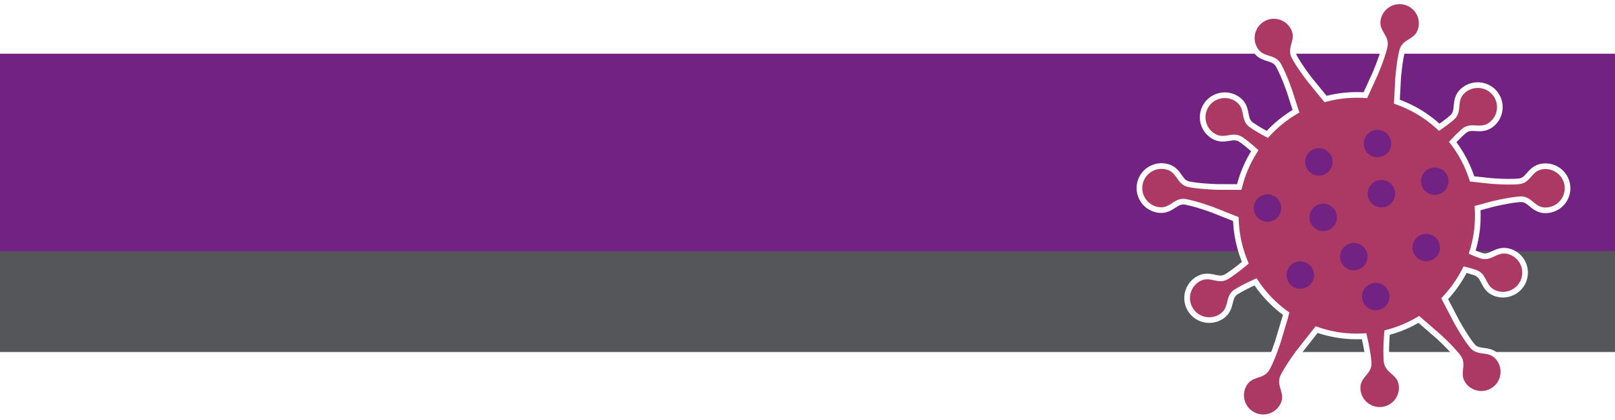

**Social Posts – COVID-19 Vaccine and Pregnancy**

**CO**RONA**VI**RUS **D**ISEASE 2019   
(COVID-19)

|  |
| --- |
| **Audience:** MarComm colleagues to post on social media |
| **Revision Date:** 2/2/2022 |
| **Version:** #1 |
| **COVID-19 Response Team Owner:** Clinical and Operations |
| **Date of Last Review:** 2/2/2022 |

Social Media Content for COVID-19 Vaccine and Pregnancy

The FDA is continuing to urge people who are pregnant to get the COVID-19 vaccine. Studies have shown that people who are pregnant or recently pregnant are at an increased risk for severe illness from COVID-19 when compared to people who are not pregnant. People who have COVID-19 during pregnancy are also at increased risk for preterm birth (delivering the baby earlier than 37 weeks) and stillbirth and might be at increased risk for other pregnancy complications.

Use the following social posts to encourage pregnant people. Social posts can be found in the following Teams folder [here](https://mytrinityhealth.sharepoint.com/:f:/r/sites/MarCommEnterpriseTeamTHO365/Shared%20Documents/Social%20Media%20Collaborative/Graphics?csf=1&web=1&e=vwC83u) or on the COVID-19 Resources page.

**Twitter – Pregnancy and MotherToBaby**

Mothers want what’s best for their babies – even before they are born. If you are pregnant and are unsure about receiving the #COVID19 vaccine, @MotherToBaby is a free resource to get answers to your questions. Visit <https://bit.ly/344gwdC> to chat with an expert.

**Facebook/LinkedIn – Pregnancy and MotherToBaby**

Mothers want what’s best for their babies – even before they are born. If you are pregnant and are unsure about receiving the COVID-19 vaccine, MotherToBaby is a free resource to get your questions answered.

Call 1-866-626-6847 or visit <https://bit.ly/344gwdC> to send an email or live chat with an expert.

**Social Graphic – Pregnancy and MotherToBaby**



**Twitter – Vaccine FAQ Pregnancy One Day**

People who plan to become pregnant are recommended to get the #COVID19 vaccine. Based on research, unvaccinated pregnant people are at an increased risk of complications or preterm birth.

Schedule your vaccine today: [Vaccines.gov](https://www.vaccines.gov/FIND-VACCINES/)

**Facebook/LinkedIn: Vaccine FAQ Pregnancy One Day**

Do you plan on becoming pregnant? If so, the CDC strongly encourages those individuals to get the COVID-19 vaccine. Based on research, unvaccinated pregnant people are at an increased risk of complications or preterm birth (delivering the baby earlier than 37 weeks) and stillbirth.

Schedule your vaccine today: [Vaccines.gov](https://www.vaccines.gov/FIND-VACCINES/)

**Social Graphic – Vaccine FAQ Pregnancy One Day**

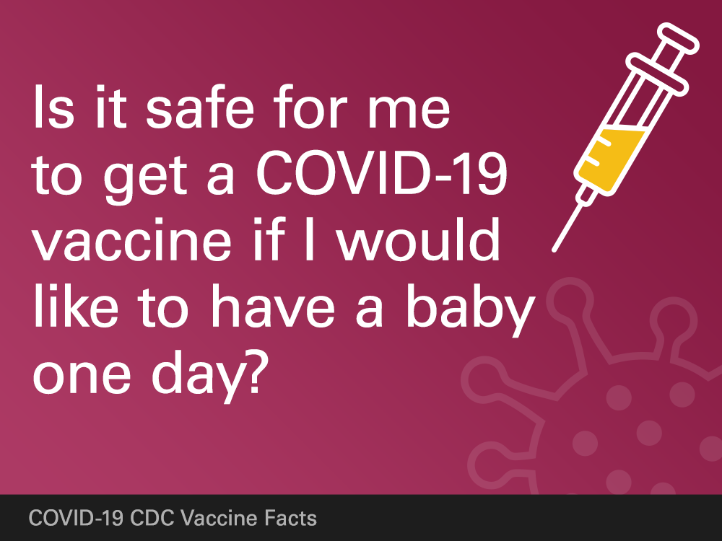

**Twitter: Pregnancy and Severe Illness**

If you’re pregnant or were recently pregnant, you’re more likely to get severely ill from #COVID19 compared to people who are not pregnant. @CDCgov recommends the #COVID19 vaccine for people who are pregnant.

Schedule yours today: [Vaccines.gov](https://www.vaccines.gov/FIND-VACCINES/)

**Facebook/LinkedIn: Pregnancy and Severe Illness**

If you’re pregnant or were recently pregnant, you’re more likely to get severely ill from COVID-19 compared to people who are not pregnant. Pregnancy causes changes in the body that could make it easier to get very sick from respiratory viruses like COVID-19.

By getting the COVID-19 vaccine, you can help protect yourself and your baby from severe illness. Fina a vaccine in your area: [Vaccines.gov](https://www.vaccines.gov/FIND-VACCINES/)

**Social Graphic: Pregnancy and Severe Illness**

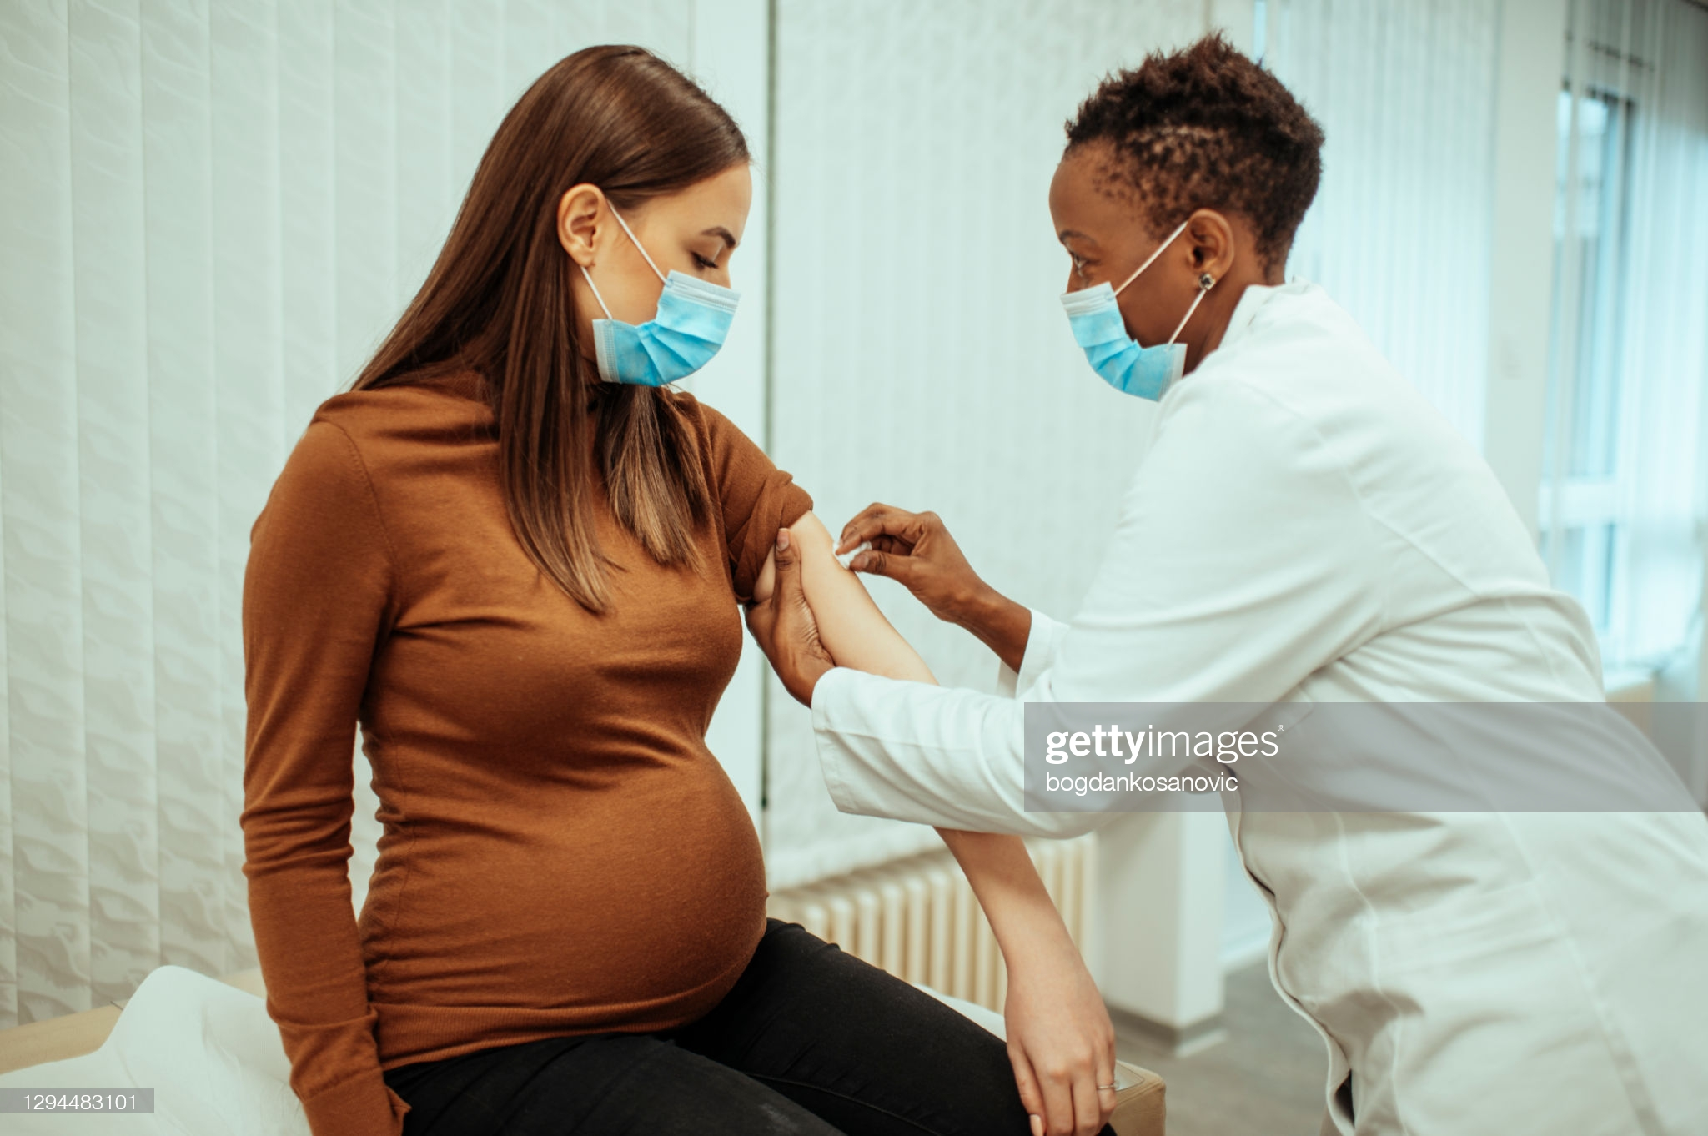

**Twitter: Protect yourself during Pregnancy**

It is crucial for people who are or were recently pregnant, and those who live or visit them, to take steps to protect themselves and their baby from getting #COVID19. Getting the vaccine, wearing a mask, and washing your hand often are some of the best ways to slow the spread.

**Facebook/LinkedIn: Protect yourself during Pregnancy**

It is crucial for people who are or were recently pregnant, and those who live or visit them, to take steps to protect themselves and their baby from getting COVID-19.

Here are some important ways to slow the spread of COVID-19 ⤵️

◾️ Get a COVID-19 vaccine as soon as you can.

◾️ Wear a well-fitting mask that covers your nose and mouth to help protect yourself and others.

◾️ Stay 6 feet apart from others who don’t live with you.

◾️ Avoid crowds and poorly ventilated indoor spaces.

◾️ Test to prevent spread to others.

◾️ Wash your hands often with soap and water. Use hand sanitizer if soap and water aren’t available

**Social Graphic: Protect yourself during Pregnancy**

