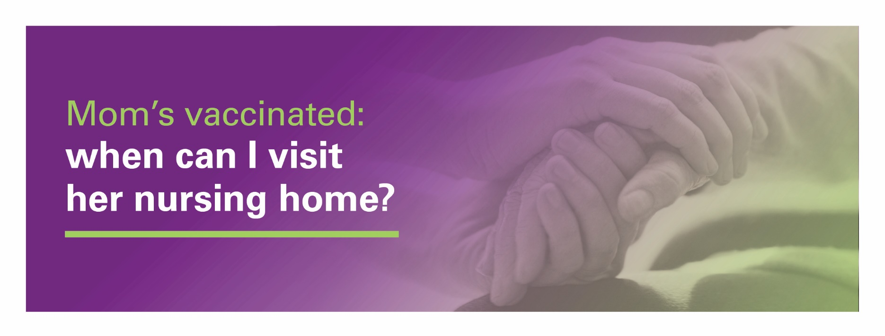It is so great that your mom, dad or other loved ones have received their COVID-19 vaccine. This is an important step toward protecting their health, achieving herd immunity, and ending the pandemic.

Trinity Health Senior Communities, CMS and CDC recognize the importance of visiting your relatives as part   
of staying healthy.

**Following CDC guidance, you can now visit your loved ones inside when:**

* The COVID-19 positivity rate in your nursing home’s county is no more than 10%, and more than 70%   
  of residents in the facility are fully vaccinated
* If there’s an outbreak in our facility, indoor visitation is possible if COVID-19 transmission is contained   
  to a single area of the facility

**How to schedule a visit with your loved ones:**

Call us directly to schedule your indoor or outdoor visit. Remember, outdoor visits are always the safer option.

We can’t wait to welcome you back to our community. We know what a long-awaited and treasured moment this is for you and for those entrusted to our care. If you have any questions before, during, or after your visit, please feel free to reach out to us.

Name of ministry

Phone number of family visit scheduler

E-mail address of scheduler

**For more information, visit** <https://www.cdc.gov/vaccines/covid-19/toolkits/long-term-care/downloads/answering-residents-loved-ones-questions.pdf>



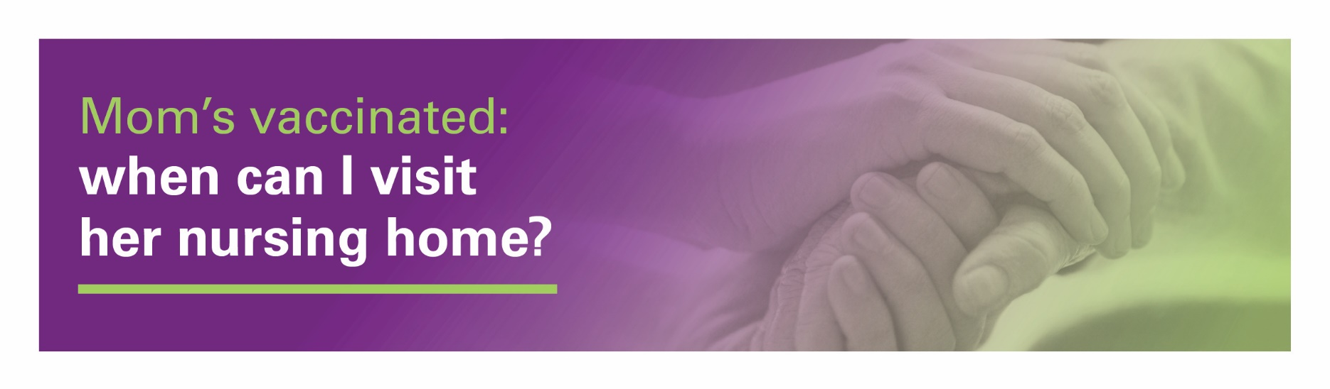**Frequently Asked Questions (FAQs)**

**Do I need to be tested for COVID-19 before I can visit?**

Visitors may be requested to take a COVID-19 test upon entry or within 72 hours prior to their visit. All visitors will   
be screened for signs and symptoms of COVID-19 by way of a temperature check and questions and/or observations.   
Any person who exhibits signs or symptoms of illness will be denied entry. We encourage all our visitors to be vaccinated as soon as they are eligible for their own protection and that of their loved one.

**My loved one is fully vaccinated. Can we hug?**

If your loved one is fully vaccinated (**two weeks after** the second dose of the Pfizer or Moderna vaccines or one dose   
of the Johnson & Johnson vaccine,) they can choose to have close contact (including touch) with you as long as you   
are both wearing a well-fitting face mask.

**Do we still have to wear masks?**

Yes. Some nursing home residents and staff are not vaccinated or are not fully vaccinated yet. To protect others, it is important we all continue to wear a mask, wash our hands and watch our distance.

**May I share a meal with my loved one when I come to visit?**

For safety purposes, sharing food during visits is not permitted.

**Is there any limit to the number of family members I bring with me to visit?**

Each resident is limited to two visitors per visit. Our leaders will set limits on the total number of visitors permitted in   
a facility on any given day; learn more when you call to schedule your visit.

**Does it matter where our visit takes place inside?**

Yes. Trinity Health Senior Communities is committed to safety. Because we want to make sure that visitation areas are properly sanitized between visits, we will let you know where our designated locations are when you call us to schedule. Whether you are permitted to go to your loved one’s residence or to another specified area, we ask that you take the   
most direct route possible after checking in with us. Guests will not be permitted to visit other areas of our buildings.

**I know that compassionate care visits are permitted. Are these only for end-of-life circumstances?**

No. End-of-life situations are one example, but our team will work with residents, families, caregivers, and resident representatives to identify any need for a compassionate care visit. Please call us so that we can discuss your loved   
one's needs.

