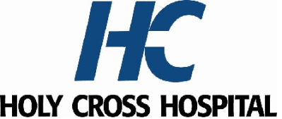
2026 MEDICAL EXECUTIVE COMMITTEE

President: Kanwaljit Nagi, M.D.
Vice President Rami Makhoul, M.D.
Secretary /Treasurer: Rachel Vile, M.D.
Credentials Chair: Zachary Levine, M.D.
Medicine Chair: Muhammad Shibli, M.D.
Surgery Chair: Matthew Skancke, M.D.
OB/GYN Chair: Alicia Odum, M.D.
Pediatric Chair: Erica Rupar, M.D.
Emergency Department Chair: Paul Baker, M.D.
Pathology Department Chair: Pablo Gutman, M.D.
Radiology Chair: Benjamin Stallings, M.D.
Anesthesia Chair: Marc Azran, M.D.

AT LARGE

Surgery: Nini Khozeimeh, M.D.
Pediatric: Chrysanthe Gaitatzes, M.D., PhD.
Medicine: Theodore Igwebe, M.D.
OB/GYN: Vera Ibe, M.D.

Holy Cross Health Representatives

Maggie Perih, RN, MSN, Chief Nursing Officer
Janis Green, M.D., Chief Medical Officer, Holy Cross Hospital
Sharon Carney, M.D., Regional Chief Clinical Officer, Holy Cross Health
Al Campbell, MBA, FACHE, RN, Market President, Holy Cross and Holy Cross Germantown Hospitals
Andre Boyd, FACHE, Regional President and CEO, Trinity Health Mid-Atlantic and Holy Cross Health in Maryland

